Excel Assignment 9

**Altaf Hussain**

**FSDA** **1**

1. What are the different margins options and do we adjust the margins of the excel worksheet?

**A**. Adjusting Margins in Excel:

First, we need to select the specific sheet to adjust margins.

Next, we need to go to the File tab and click the Print option from the list.

Excel displays various printing options in the next window, such as choosing the number of copies to the print, default printer, page orientation, scaling, margins, etc. We have to click on the Margins option to access available margins in Excel.

2. Set a background for your table created.

**A**.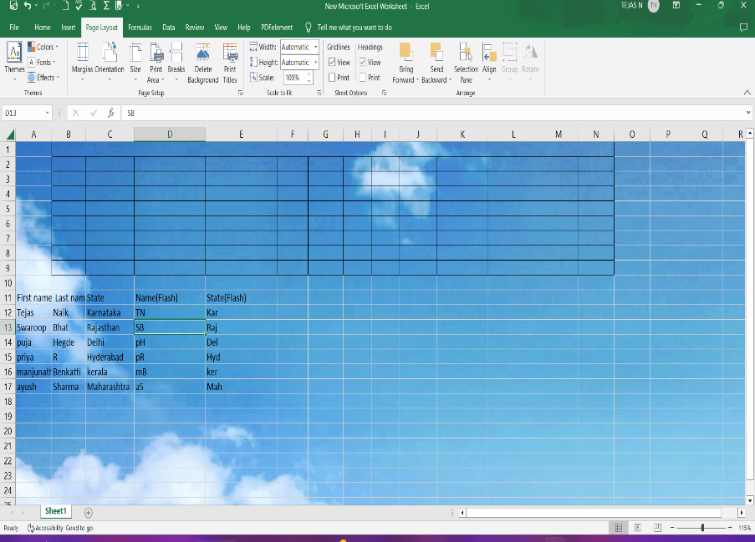

3. What is freeze panes and why do we use freeze panes?

**A**. The Excel Freeze Panes option allows you to lock your columns and/or rows so that when you scroll down or over to view the rest of your sheet, the column and/or row will remain on the screen.

4. What are the different features available within the Freeze Panes command?

A. If you apply the Freeze Pane option of Excel freeze pane feature, it can freeze the row and column simultaneously at the same time.

Freeze pane, Freeze Top row, Freeze First column.

5. Explain what the different sheet options present in excel are and what they do?

A. Since an Excel sheet is one of the core elements of the workbook, there are multiple core options to perform from the Sheet Options. We can access various sheet options by using the following ways:

Ribbon Sheet Options

Right-click Sheet Options

Ribbon Sheet Options

Excel has all the basic and advanced options present on its ribbon. Likewise, some quick sheet options are also present on the Excel ribbon and can be accessed by going to Page Layout > Sheet Options. It mainly has four toggle options: two for Gridlines and two for Headings, and they can be turned on and off by selecting and deselecting the checkboxes.

**Gridlines**:

View: This option allows users to show/ hide gridlines within the active worksheet. Turning off this option removes the gridlines from the sheet and displays a blank Excel sheet.

Print: This option allows users to show/ hide gridlines on an Excel document that will be printed on paper.

Headings:

**View**: This option allows users to show/ hide headings within the active worksheet. Turning off this option removes the headings from the current sheet's headers and footers.

**Print**: This option allows users to show/ hide headings on an Excel document, which is to be printed on paper.